Impact and Relevance
For over a century, technologists and scientists have actively sought the development of exoskeletons to augment strength and endurance. The country’s disabled population has increased by 22.4% between 2001 and 2011. As the number of disabled people is increasing, there is a need of a support system in the society. The project is basically a cheap exoskeleton which can be worn by patients for aiding walking and faster recovery after accidents. We believe that this exoskeleton will let those patients live a normal, independent life. While there are still many challenges associated with exoskeleton design that have yet to be perfected, the advances in the field have been truly impressive. Healthcare is channelling the future to present times by utilizing robotic technologies. The biped exoskeleton covers a broad spectrum of embodiments, assisting individuals suffering from limb pathology in order to augment normal, intact limb function. The term “exoskeleton” describes systems that are more than just a passive protecting and supporting shell. Following project is inspired by exoskeletons and rehabilitation solutions like ReWalk and Lokomat.
Introduction to BipEx
BipEx is a system developed for patients who do not have or have lost, either partial or complete, control over their legs. Instead of paying large sums of money for treatment, the patient can use this cheap and economical rehabilitation system which will help the patient recover faster. Such rehabilitation systems are rarely used in India. It can help the patient walk at enhanced speeds and with reduced efforts and metabolic cost.
The User Interface lets the users keep a track of his/her muscle activity and lets the user communicate with the system. The components are simple and allow for the design of low weight parts with complex geometries. Sensors and electronics are incorporated for developing an adaptive control scheme for the exoskeleton using sensor feedback.

LABVIEW
AI2
DIO2DIO
DIO3
DIO0
DIO1
Complete System Diagram
AI1
Mains Supply
12 V
Relays
EXOSKELETON
myRIO
EMG Sensor
Pulse Sensor
Compressor

Computer
AC
On-Board Storage

P2
P1
P3

P4

S1
S4

S2

S3

Pistons
Solenoids

Structure and Actuation
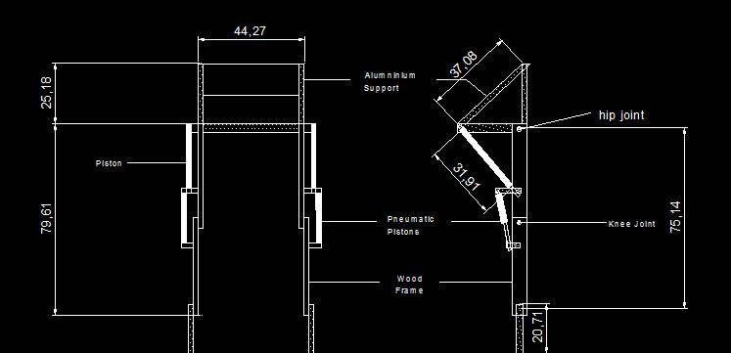
Design of BipEx in CAD

Components & their Functions-
- Framework-Consists of Wood and Aluminium as shown above. Forms Main body of exoskeleton
- Pneumatic Pistons-Their Movement is responsible for Actuation(linear)
- On board Air Storage-We used Plastic Water bottles(in first prototype) and will use same second prototype also
- Solenoids-used to switch the direction of air flow in pistons.
- Compressor-provides compressed air for working

Working-
When Compressed air is supplied to a compartment of Piston, it moves to the other side. Since piston is attached to wooden frame as shown, linear movement is converted to rotational movement of joint. This flow of compressed air and hence the motion of joints is controlled by a solenoids which in turn are controlled from myRIO.

Pseudo Code for the movement-
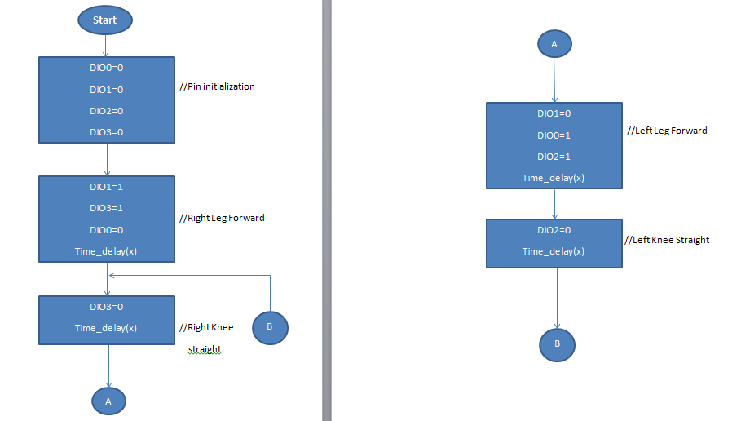

- DIO0->Left Hip Joint
- DIO1->Right Hip Joint
- DIO2->Left Knee Joint
- DIO3->Right Knee Joint

Sensor Module

- Infrared Pulse Sensor

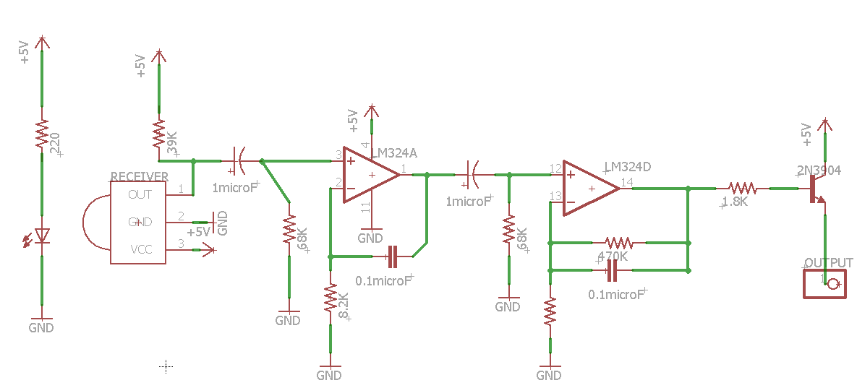
Circuit Schematic

The circuit contains an infrared emitter and detector mounted side-by-side and pressed closely against the skin. When the heart pumps, blood pressure rises sharply, and so does the amount of infrared light from the emitter that gets reflected back to the detector. The detector passes more current when it receives more light, which in turn causes a voltage drop to enter the amplifier circuitry.
This design uses two consecutive operational amplifiers (“op-amps”) to establish a steady baseline for the signal, emphasize the peaks, and filter out noise. Both op-amps are contained in a single integrated circuit-LM324. The two op-amps output a clean but weak signal which is amplified by the transistor before output.

- Electromyography(EMG) Sensor
The electromyography sensor circuit takes values when electrodes are placed on the skin over the muscles and generates signals which is filtered and converted to a corresponding DC voltage which is sent to the microcontroller for plotting graphs and measuring the muscle activity of the patient with time.
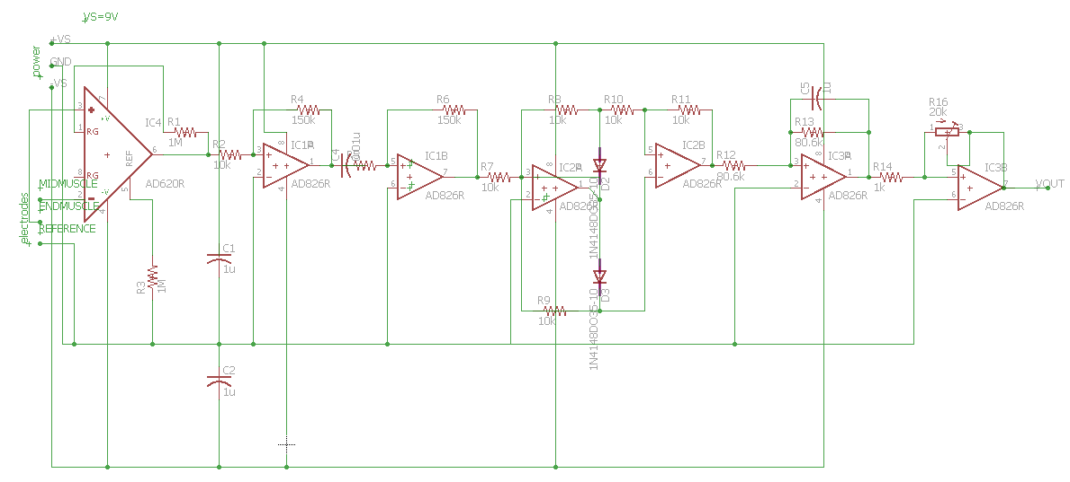
Circuit Schematic
.
The electromyography sensor circuit consists of the following phases:-
- Power supply- To power the circuit.
- Signal acquisition-It is used to measure body's nervous system's electrical impulse used to activate muscle fibres. The INA106 amplifier will measure and amplify the small voltage differences between the two electrodes placed on the muscle.
- Signal conditioning (amplification)-In this phase, we take small signals measured in signal acquisition phase and amplify them.
- Signal conditioning (rectification)-In this phase, we rectify the signals using an all wave rectifier. We will use a low pass filter to turn our AC signal into a DC voltage, readying the signal to be passed to a microcontroller.
- Signal conditioning (smoothing + amplification)-In this last phase, we will use an active- low pass filter to filter out the humps of our signal to produce a smooth signal for our microcontroller.
The Intelligent Node-myRIO
Functionalities of myRIO:
- Receive the analog inputs from the sensor modules.
- Command the movement of the exoskeleton through DIO.
- Connect the user interface to the system.

Timeline
Up to 6th august :  (exoskeleton’s structure design) | - Researching and Developing a Detailed Implementation Plan  - System Architecture  - Mechanical Structure  - Sensor Modules  - myRIO Architecture  - LabVIEW  - Building wood/aluminium structural framework (Structural design)  - Installing pistons and solenoids for Actuation  - Developing an Algorithm and Code for the prototype  - Testing the code on an ordinary microcontroller (temporarily)  - Final connections of circuit, completing external circuit and testing the prototype  - Side by Side development of User Interface using LabVIEW
6th august Onwards  (improving exoskeleton’s structure and working on electronic sensors) | - Strengthening and Rebuilding the exoskeleton framework to make it better (8-10 days)  - Making electromyography and pulse sensor modules (3-4 days)  - Adjusting pistons and solenoids to work in coordination (2 days)
Working with LABVIEW and myRIO: | - Developing the algorithm for exoskeleton using LabVIEW and interfacing it with myRIO (5-6 days)  - Interfacing the solenoids with myRIO (1-2 days)  - Interfacing Sensors Modules (EMG & pulse) with myRIO and simultaneously working on VIs of the project (7-8 days)  - Testing sensors with the exoskeleton using LABVIEW (4-5 days)  - Putting everything in Place  - Enhancing the GUI made for the user  - Final modifications

Graphical User Interface

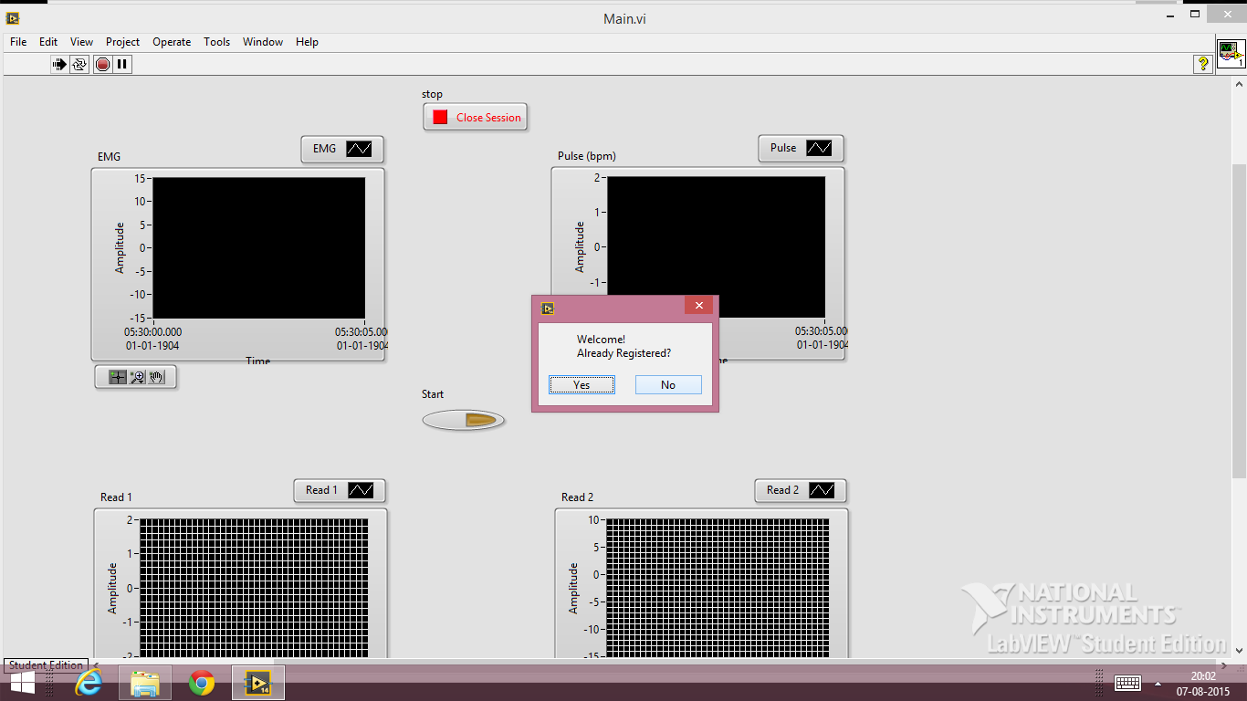
Welcome Screen

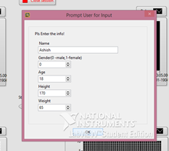
File Saving (once as spreadsheet and twice as .lvm file)
Registration for New User

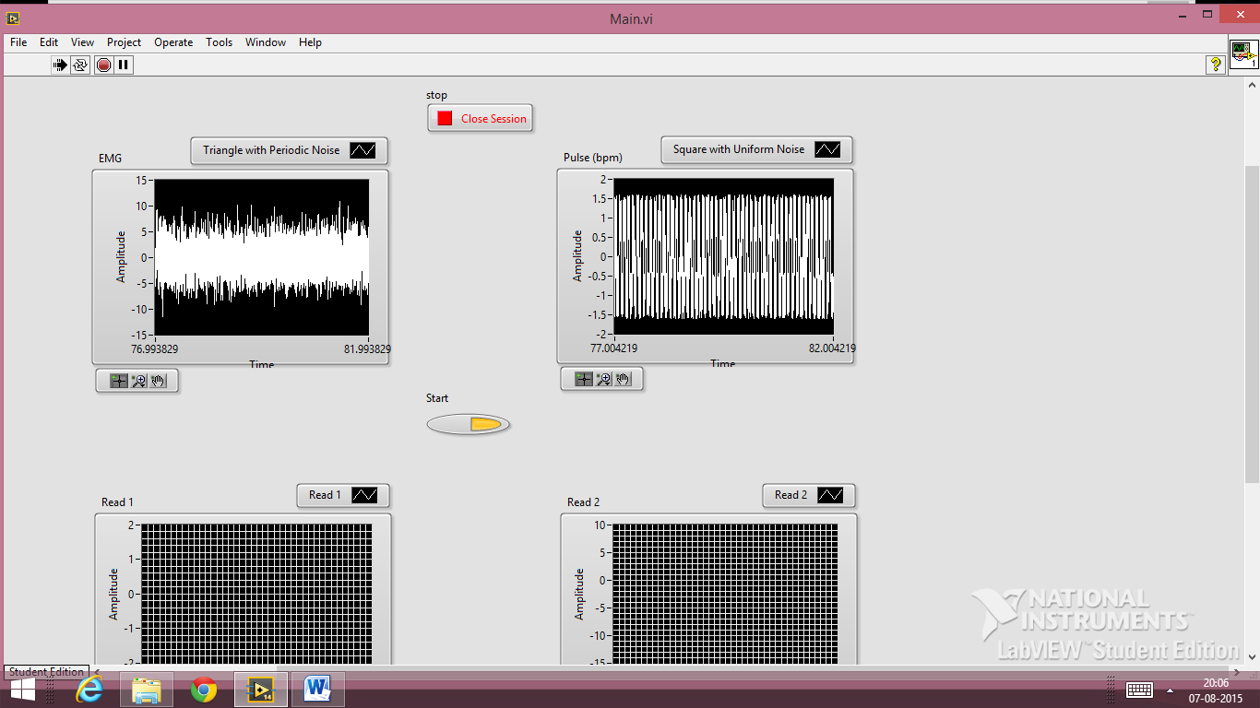
Real-Time Data Acquisition

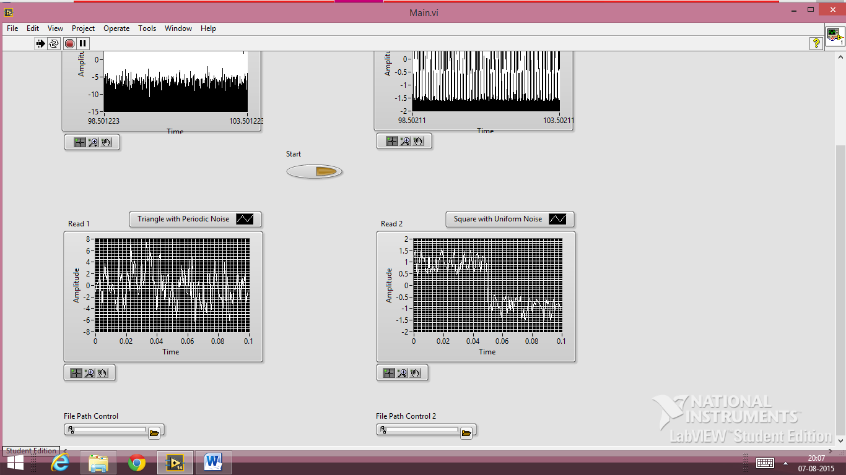
Reviewing Saved Data

In Future, User Interface will also be developed in terms of intuitiveness, file handling, additional features like access with user name and password, etc.
Other features like Automation control using EMG inputs, etc. are also to be incorporated.

Screenshots of the first prototype:
